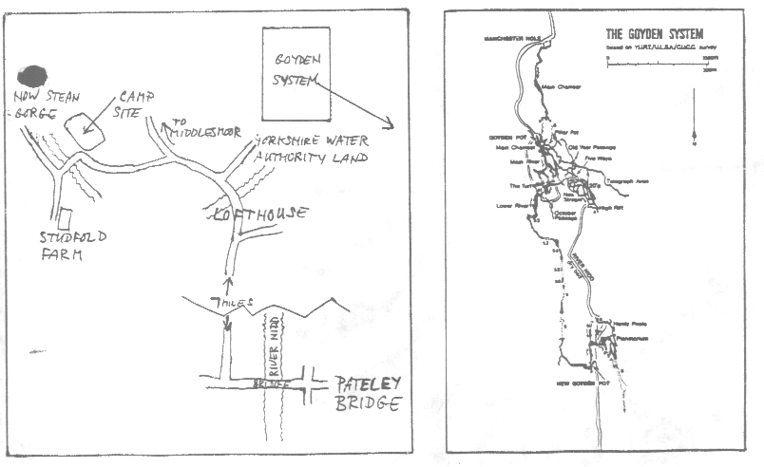
NOT QUITE T H E M O R L E Y P O T H O L E C L U B (JUST YET)

NEWSLETTER NUMBER ONE

WEEKEND MEET IN NIDDERDALE - SATURDAY/SUNDAY 17TH/18TH SEPTEMBER 1988

Three caves are on the agenda for the weekend, which between them offer a good opportunity for the uninitiated to become 'blooded' (only figuratively speaking) but are also varied in complexity, giving an interesting trip for all comers. Manchester Hole is a simple but quite impressive stream passage entered alongside the normally dry bed of the River Nidd. In contrast Goyden Pot is a system with passages totalling over two miles in length. It is a '..complex and impressive major river cave with a variety of routes of differing grades (of difficulty), containing massive caverns and a maze of passages..' New Goyden Pot is the third cave which completes the 'Goyden System'. It is described as A major river cave with a superb railway-tunnel sized main streamway`. The main stream passage is reached via two pitches, 50ft and 40ft high respectively.

The alternative to caving on the Sunday would be to try some rope and ladder practice down How Stean Gorge - the choice is yours.

You will need to take warm (old) clothing and preferably waterproof over clothes. Either old walking boots (not with hook lacings) or wellies are equally suitable. If you can't get hold of your own lamp we can hire them at a small charge (a few pounds) but please let us know in advance as they will have to be booked. Similarly with helmets.

Camping is at Studfold Farm (see below) and costs £1.50 each/night including tent and one car/bike. If you do not camp on the Friday night, meet at the camp site between 10.00 and 10.30am on the Saturday morning. Hope to see you there.
Phone for equipment, either 539007 or 531171.

